Feature List Template CMZ TD-Series

Please modify the information below to meet the machines features that we would like users to be aware of.

**Supported Features**

* Fanuc i-TB series – Operate interface
* Upper Turret operations
* Performs milling/Turning operations using single pieces stock
* Performs cut-off strategy
* Polar Coordinate interpolation (G12.1)
* The machine uses three different streams. One for the upper turret, one for the lower and the third for the use of the tailstock, which is located above the right spindle.

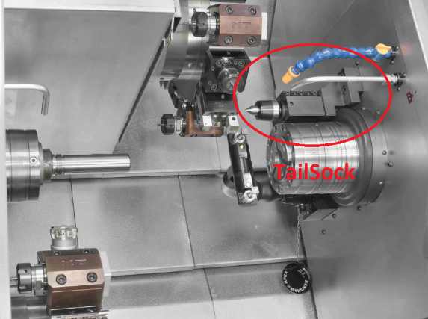

the tailstock has a translation axis which allows the use of the tailstock at the same time as the right spindle. What is not yet possible to do on Mastercam. We have chosen to use only the left and right spindle streams on this post processor. Basically, this machine uses the three streams to make a part transfer. We modified it to use it only on two. Thus, we facilitate the use of the Mill turn for the customer. The tailstock is therefore not supported on this machine.

You will find actual supported feature lists on our Mastercam webpage.

<https://www.mastercam.com/en-us/Support/Posts/>